# Graphical user interface Description automatically generated with medium confidenceIdentifying Emotions

Instructional Outline and Visual Supports

**Instructions:** Use this instructional outline as the lesson plan and the “Identifying Emotions” script for teaching emotion identification. Use the supplemental visuals to support student engagement and understanding.

|  |  |
| --- | --- |
| Materials Needed | “I Do” Table, Emotion Face Bank, Physical Feelings Bank, Physical Feelings Map |
| Lesson Goal | To identify emotions both visually and physically. |
| Introduction | **[Introduce the lesson.]** *“Today we are going to be talking about different emotions. Emotions are our body’s way of telling us how to respond to events happening to us. We all have a lot of emotions, and they may look and feel different for everyone!”* |
| Model (I Do) | **[Create an “I Do” table using reference material. Can print or draw on board.]**    **[Use the first row in the “I Do” table below to demonstrate identifying emotions.]** *“This table will help you understand what your emotions look like and feel like. Let’s see how we can use it!”*  **[Point to the Emotion box.]** *“When I am happy, I might smile like this* **[point to your face or face in the Looks Like box]**, and *I may feel calm in my heart* **[point to the Feels Like box]**. *Let’s take a look at some other emotions.”*  **[Using the sentence frame below and the “I Do: Identifying Emotions Table,” provide additional examples of emotions with your students.]**  *“When I am [emotion word], I look like [point to emotion face], and I feel [point to physical sensation and/or location].”*  **Example Physical Sensations and Locations for Each Emotion:**   * **Happy**: Calm heart * **Sad**: Teary eyes * **Angry**: Hot face * **Worried**: Shaky legs * **Disgust**: Queasy stomach   **Instructional Notes:**   * If your student(s) need(s) more models, provide additional examples from book or story characters familiar to your student(s). |
| Guided Practice (We Do) | **Guided Practice 1: Students identify facial expression for “Looks Like” box for each emotion**  **Option 1: Select face from array (receptive identification).**  *“Now, let’s practice together. For each emotion, pick a face from your Emotion Face Bank that you think looks like the emotion. Let’s take ‘’happy.’ What does your face look like when you feel happy? Remember, different faces can show happiness. Choose one that you think best shows ‘'happy’ for you.”*  Note: The display can be adjusted to whatever is best for your student. This can include drawing a smiley face, acting it out, practicing their facial expressions in a mirror, etc.  Note: You may adjust the array to whatever number you would like. You can have a small array by having the students pick one face out of three options, or you can increase the array to include up to 30 options on the Emotion Face Bank.  **Option 2: Produce face (expressive identification).**  *“Now, let’s practice together. Go down the list and show me how each emotion looks. Let’s take ‘happy.’ What does your face look like when you feel happy? Remember, how happy looks on you may look different than how happy looks like for others.”*  **[Using the “We Do: Identifying Emotions Table,” complete the remaining “Looks Like” sections for the remaining emotions.]**    **Guided Practice 2: Students identify physical feelings for the “Feels Like” box for each emotion**  **Option 1: Select sensation word(s).**  *“Now, let’s practice together. For each emotion, circle the words on your physical feelings bank that best describe how your body feels for that emotion. Let’s take’ happy.’ What do you feel when you are happy? Remember, ‘happy’ feels different for everyone. Choose the words that describe how happy feels like for you.”*  Note: You may adjust the array to display all words from the bank or just some sections (i.e., voice, face, and/or body). Students may select more than one word and/or can circle, underline, or highlight responses.  **Option 2: Select physical location(s).**  *“Now, let’s practice together. For each emotion, point to where you feel it on your body using your finger or your physical feelings map*. *Let’s take ‘’happy.’ Where do you feel ‘happy’ in your body? Remember, people can feel ‘happy’ in all different places. Choose where you feel happy.”*  Note: You may have students select the location on the physical feelings map by coloring or circling where they feel that sensation OR by pointing to the location on their own body.  **Option 3: Combine sensation word(s) with physical location(s).**  **[Using the “We Do: Identifying Emotions Table,” complete the remaining “Looks Like” sections for the remaining emotions.]**    Instructional Notes:   * If time allows, go through both guided practice activities. If time does not allow, start with Guided Practice 1.   + If guided practice activities are separated, repeat the “I Do” model before going into Guided Practice 2. * Monitor student responses to gauge understanding of concepts and to identify if additional practice is needed. |
| Independent Practice (You Do) | Monitor student responses to gauge understanding of concepts; use student responses to identify if reteaching or additional practice is needed |

Visual Supports

|  |  |
| --- | --- |
| Page 5 | I Do: Identifying Emotions Table |
| Page 6 | We Do: Identifying Emotions Table |
| Page 7 | Emotion Face Bank |
| Page 8 | Physical Feelings Bank |
| Page 9 | Physical Feelings Map |

[The Ekmans' Atlas of Emotions](https://atlasofemotions.org/)

This resource series was developed by TRIAD consultants and was made available at no cost through the Tennessee Department of Education, Tennessee Technical Assistance Network. [Triad.vumc.org/schools](https://vkc.vumc.org/vkc/triad/live-training/). 2024

I Do: Identifying Emotions Table

|  |  |  |
| --- | --- | --- |
| **Emotion** | **Looks Like** | **Feels Like** |
|  | [Face from Emotion Face Bank] *or* [Draw Face] *or* [Model Face] | [Word from Physical Feelings Bank and/or Location on Physical Feelings Map] |
| **Happy** | Smiling face outline with solid fill | Calm heart |
| **Sad** |  |  |
| **Angry** |  |  |
| **Worried** |  |  |
| **Disgust** |  |  |

We Do: Identifying Emotions Table

|  |  |  |
| --- | --- | --- |
| **Emotion** | **Looks Like** | **Feels Like** |
| **Happy** |  |  |
| **Sad** |  |  |
| **Angry** |  |  |
| **Worried** |  |  |
| **Disgust** |  |  |

**Emotion Face Bank**

     

     

     

     

     

Physical Feelings Bank

**Voice:**

* Roar
* Sharp
* Laugh
* Sigh
* Quiver
* Cry

**Face:**

* Eyes
  + Wide Open
  + Glaring
  + Squinting
  + Teary
* Eyebrows
  + Raised
  + Lowered
  + Pushed Together
* Mouth
  + Smile
  + Frown
  + Pressed Lips
  + Tongue Out

**Body:**

* Hot
* Cold
* Warm
* Cool
* Tense
* Relaxed
* Tired
* Energetic
* Weak
* Heavy
* Light
* Breathless
* Achy
* Queasy
* Calm
* Excited
* Jumpy
* Electrified
* Relaxed
* Steady
* Unsteady
* Numb
* Shaky
* Hurt
* Sweaty

Physical Feelings Map

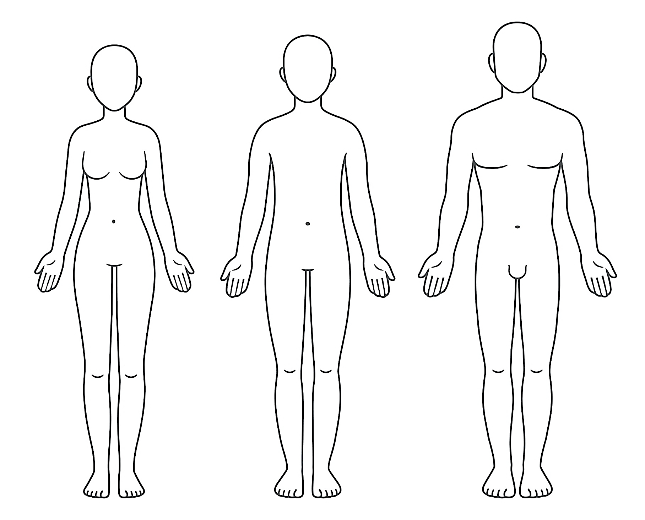

**Head and Face**

**Heart and Chest**

**Arms and Legs**

**Belly and Body**