Grounding
Intervention Planning Guide
This is an example. Please modify to reflect the needs of your student or students.
SMART Goal  *reference SMART goal setting guide | Example: By [date], given the Grounding Graphic Organizer, [student] will independently complete each step in the grounding exercise.
Baseline | Baseline context: | e.g., During homeroom 1:1 or during small group session with [school counselor or school psychologist]
Baseline | Baseline data type and dates: | [Frequency count of steps completed independently]  [Date]
Intervention | Date intervention plan created: | [Date]
Intervention | Who implements plan: | e.g., counselors, school psychologists, special education teachers, paraeducators
Intervention | What materials are needed: | Grounding Instructional Outline, Grounding Graphic Organizers, Grounding Task Analyses, and any objects to use for grounding
Intervention | How the intervention is delivered, including any reinforcement procedures: | Teaching Trials:  - Use the Instructional Outline below to teach the grounding exercise to [student].  - Use visuals to support understanding.  - Reinforce (e.g., token, points, praise, etc. based on student preference assessment) approximate and correct responses.  Practice Trials in 1:1 session:  - When [student] is in a calm, well-regulated state, have [student] practice the grounding exercise.  - Provide [student] with the Grounding Graphic Organizer or another grounding exercise visual to support independent practice.  - Provide [student] with reinforcement after they practice grounding. Consider the use of a First-Then visual, if needed to support practice.  Generalization to classroom:  - Once [student] can demonstrate the skills in a 1:1 or small group setting, with [student] input, review their daily schedule and determine two 3- or 5-minute time periods when [student] is in a calm, well-regulated state to practice grounding. Consider slowly adding these practice opportunities to [student’s] schedule and make sure to give [student] plenty of notice before adding grounding practice to the schedule.  - Provide [student] with the Grounding Graphic Organizer or another grounding visual to support independent practice.  - Provide [student] with reinforcement after they practice grounding. Consider the use of a First-Then visual support if needed to support practice.
Intervention | Date and context for initial implementation: | 1:1 each time with [student]. [date]
Ongoing Intervention  Data | Data collector: | e.g., counselor during teaching session, special education teacher during classroom practice
Ongoing Intervention  Data | Intervention data type: | Frequency count of student independently completing the five steps in the grounding exercise
Ongoing Intervention  Data | Mastery criteria: | Completing 4 out of 5 (80%) steps in the grounding exercise with visual support as needed
Ongoing Intervention  Data | Adjustment criteria: | If student is not engaging in grounding during scheduled times, offer the student an alternative coping strategy to try (e.g., break, breathing, asking for help, etc.).
Plan Review | Implementation review: | Future meeting to review data scheduled for:  [date]: Review implementation and adjust if needed.  [date]: Review initial data and adjust if needed.
Plan Review | Plan fidelity  Rate 0-5: 0 = not at all  3 = somewhat  5 = completely | Team independence: [insert rating], [ date]  Team fidelity; [insert rating], [date]
Plan Review | Quantity or dosage of implementation | e.g., counselor works with [student] weekly for [X] minutes.
Plan Review | Plan execution  e.g., dates, performance data, decisions and changes:  *complete at first review meeting | [date]: Implementation reviewed (e.g., staff will begin prompting the student to practice grounding by providing Grounding Graphic Organizer and providing reinforcement for every attempt to engage in grounding.)

Grounding Instructional Outline

Instructions: Use this instructional outline as the lesson plan and script for teaching grounding. Use the visual supports and activity sheets to support student engagement and understanding.

Materials Needed | Grounding Graphic Organizers/visual supports, Grounding Graphic Organizer poster, and Grounding Instructional Outline; items to see, feel, hear, taste, and smell
Lesson Goal | Student(s) will be able to complete a teacher-led grounding exercise with visual supports.
Introduction | “We are going to learn a strategy called grounding. Grounding is when we use our five senses to pay attention to our surroundings. ​Practicing grounding might help us feel safe, calm, or focused.”
Teaching Trials
Model (I Do) | First, I’ll show you how I use my sense​​s to pay attention to my surroundings. I’ll use my eyes to see five things in the room. I’ll use my hands to touch four things. I’ll use my ears to hear three things [listen for 5-10 seconds, name clear sounds]. I’ll use ​​my nose to smell two things. I’ll use my mouth to taste one thing. As I pay attention to what’s around me, I’m going to remember to breathe in through my nose and out through my mouth.”
Guided Practice  (We Do) | [Use the 54321-task analysis as a model as described above.]  “Now, ​​let’s try together.​​ First, let’s use our eyes to find five things in the room. Notice what the items look like, their shape, color, texture.”  [Have student(s) each identify one thing in the room they see and have student(s) add items to their Grounding Graphic Organizer.]  “Next, let’s use our fingers to find four things we can touch in the room. Notice what the items feel like. Are they soft? Hard? Rough? Smooth?”  [Have student(s) each identify one thing in the room they can touch and have student(s) add items to their Grounding Graphic Organizer.]  Instructional Notes:  - As you read through the script, point to each of the five senses on the 54321-task analysis.  - Provide frequent reinforcement and praise throughout lesson.
Independent Practice (You Do) | [Now have student(s) finish adding items to the last three senses boxes on their Grounding Graphic Organizer.]  “Now it’s your turn. Find three things you can hear [provide prompts if needed]. What do you notice about the sounds you hear?”  “Now, find two things you can smell. What do you notice about the smells? Are they familiar or new smells? Do you like how they smell?” [Provide prompts if needed.]  “Now, find one thing you can taste. What do you notice about the taste and texture?” [Have appropriate edible items available if needed.]
Reflection/Closure | [Ask student(s) questions to assess their understanding and potential usefulness of the strategy. Modify the types of questions and response options based on the student’s learning profile and communication preferences. Some examples of questions could be:]  On a scale of 1-10, 1 being easy and 10 being hard, how hard was this strategy to do?  Point to the picture/sense that was easiest to focus on.  Point to the picture/sense that was hardest to focus on.
Practice Trials in 1:1 Session
“We are going to practice grounding. Remember, grounding is when we use our five senses to pay attention to our surroundings. ​Practicing grounding might help us feel safe, calm, or focused.”

[Use the script above as a guide student(s) as they use their Grounding Task Analysis to go through the grounding exercise.]

Generalization to Classroom | - Once [student] can demonstrate the skills in a 1:1 or small group setting, with [student] input, review their daily schedule and determine two 3- or 5-minute time periods when [student] is in a calm, well-regulated state to practice grounding.  - Consider slowly adding these practice opportunities to [student’s] schedule and make sure to give [student] plenty of notice before adding grounding practice to the schedule.  - Provide [student] with the Grounding Graphic Organizer or another grounding visual to support independent practice.

Grounding Graphic Organizers

 | 

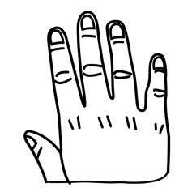

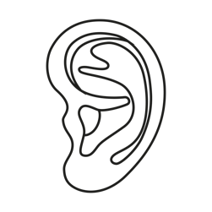

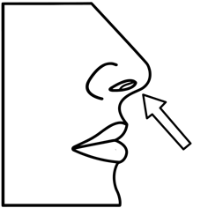



 | 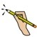

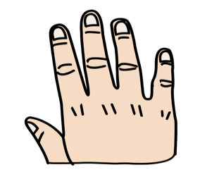

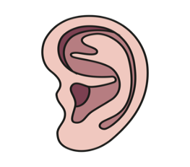

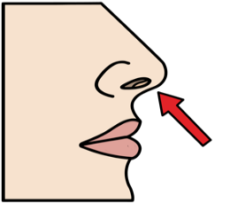



Grounding
Task Analyses

 | 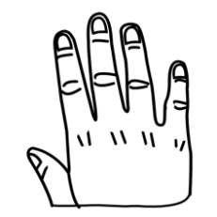 | 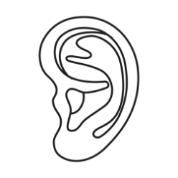 | 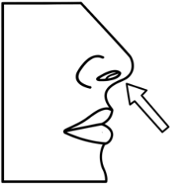 | 
5 | 4 | 3 | 2 | 1

Visuals were created using images from Smarty Symbols. All rights reserved worldwide.
 | 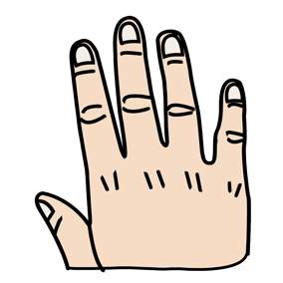 | 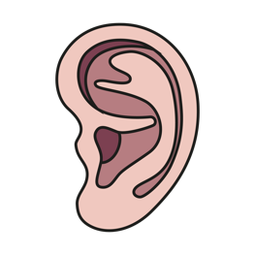 | 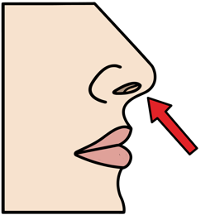 | 
5 | 4 | 3 | 2 | 1

